**DOCUMENTATION:**

**By: Meghana S Seshasai (2021B5A72517G)**

**Anushka Sethi (2021B3A71074G)**

**Chandrika Singh Jadon (2021B1A72939G)**

**Case 1:**

**Input:**

Number of courses = 15

Number of faculty = 15

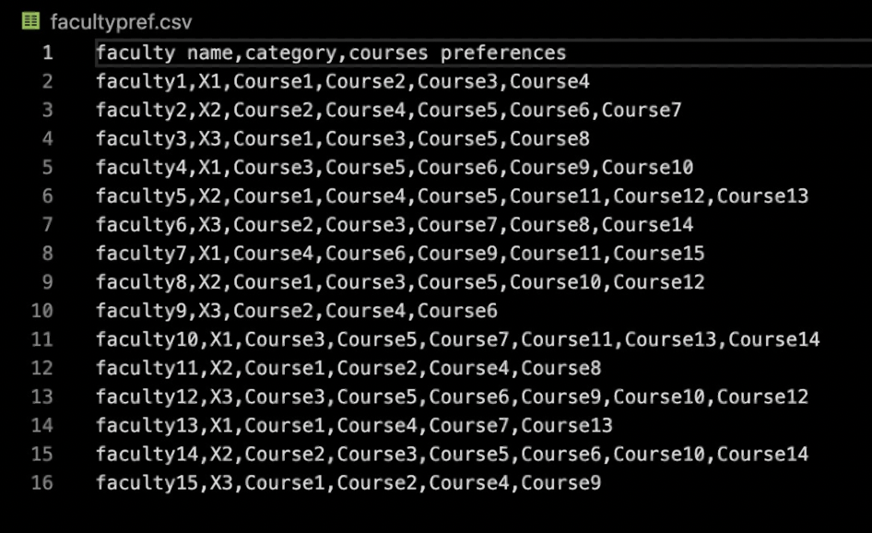

**Output:**

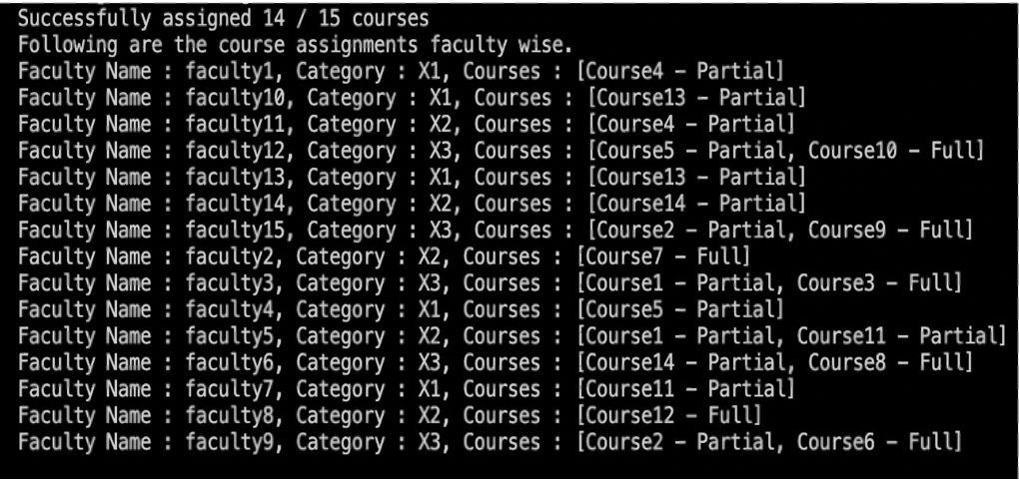

**Case 2:**

**Input:**

Number of courses = 10

Number of faculty = 15

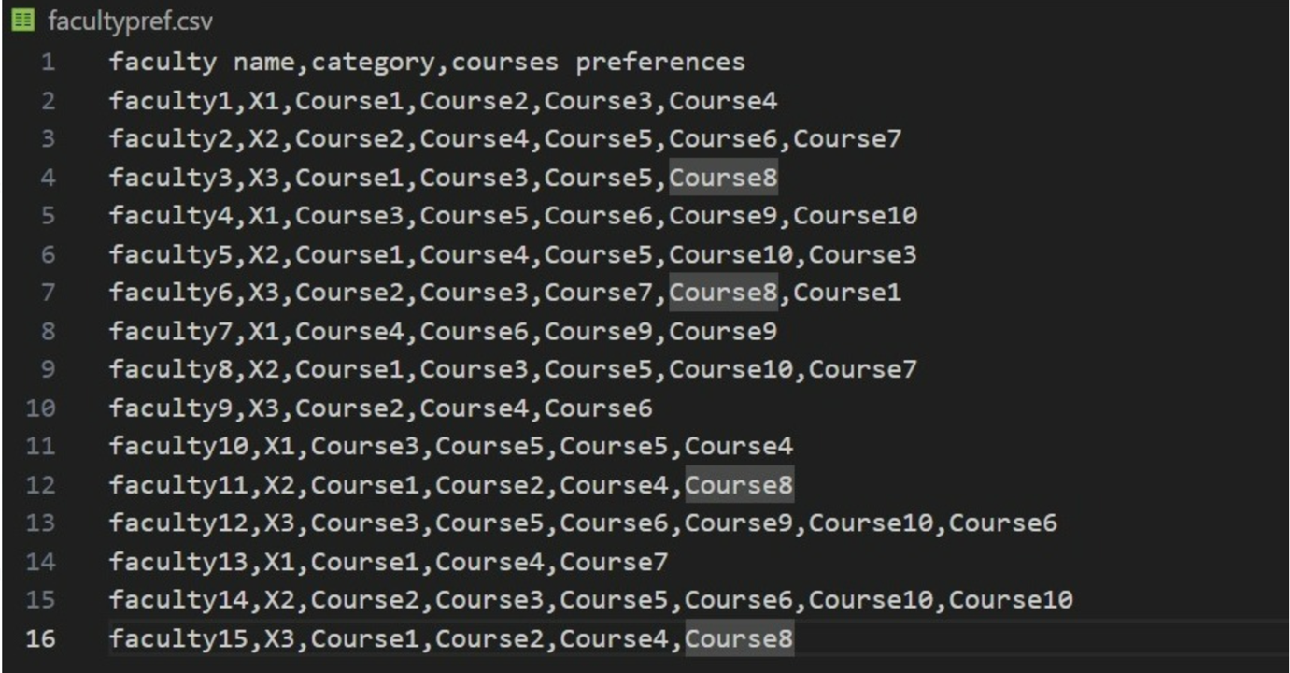

**Output:**

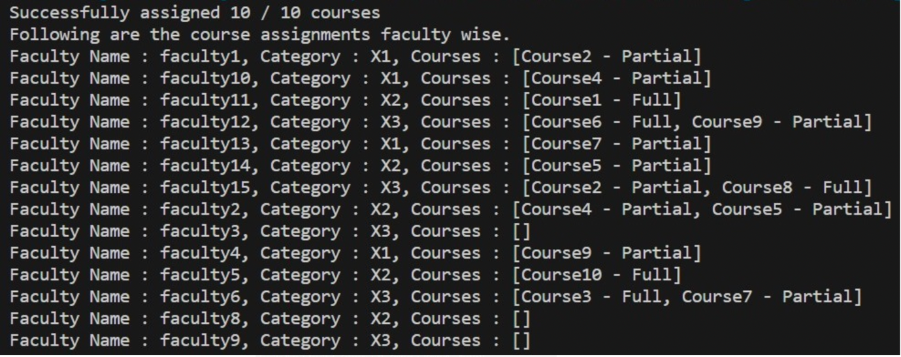

All courses are assigned, some faculties aren’t assigned anything because there aren’t enough courses to assign.

**Case 3:**

**Input:**

Number of courses = 10

Number of faculty = 5

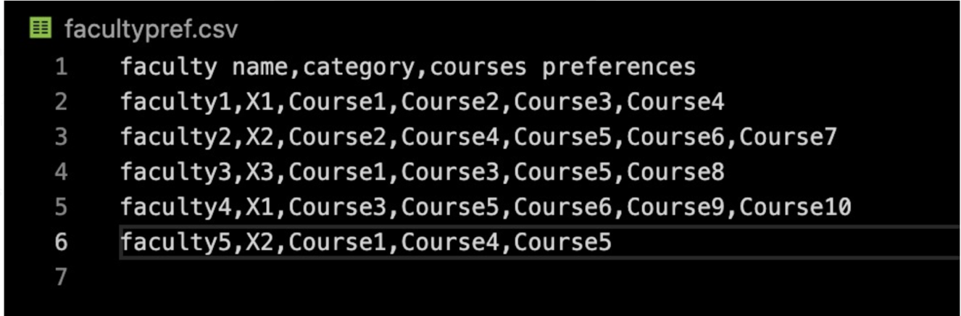

**Output:**

